SILENT ONES

Silent Ones debut feature film by Ricky Rijneke.
Young Hungarian Csilla (Orsi Tóth) wakes up inside a crashed car in the middle of nowhere, not knowing where her brother Isti is. He has vanished without a trace. As she promised him, she boards a freighter to find a new life. Then the shady Gábor (Roland Rába), a self-proclaimed businessman crosses her path. Hallucinating surrealist trip in the twilight zone between life and death.
Silent Ones premiered in Competition of the 42th International Film Festival Rotterdam Nominated for the Tiger Award.
It was screened at many mayor and independent film festivals such as
T Mobile New Horizons (Nomination Grand Prix), Sarajevo Film Festival, Mostra São Paulo (Nomination New Directors Award), Moscow Film Festival, New York, Berlin, Los Angeles, Toronto and many others.

Silent Ones won eleven awards out of fifteen nominations, among others Best Director, three times Best Film and three times Best Cinematography.

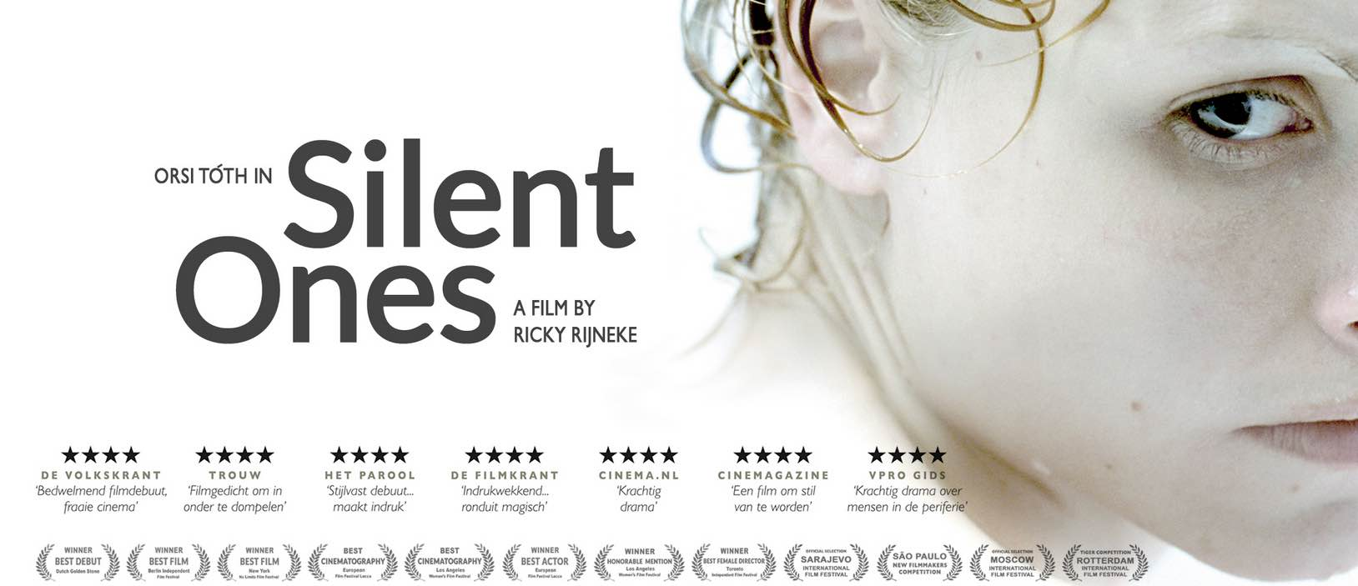

Quotes SILENT ONES
– The Hollywood Reporter:
‘Arty thriller Silent Ones has an intriguing set-up and a stylish look, visually ravishing.’

– International Cinephile Society:
‘The chemistry between the two is amazing. It is somewhat reminiscent of Bruno Dumont’s Hors Satan, only much softer and warmer. A powerful, very self-assured debut, Silent Ones confirms that the director is one to watch.’

– Slow Criticism Festivalists:
‘Impressive first feature, ingenious non-linear structure. Echoes of great European directors like Tarkovski or Béla Tarr.’

– Jim Stark, American Independent Producer (a.o. Jim Jarmusch):
‘With gorgeous visual imagery and an elliptical but very poetic story, her debut film Silent Ones has earned Ricky Rijneke a place among Europe's best young up and coming directors.’

– Danny Lennon, Curator Film PHI Centre Montreal:
“Outstanding film debut. Attention talent! One of the best films I saw at the International Film Festival Rotterdam.”

– Jos Stelling (film director) Jury president Netherlands Debut Film Festival:
‘The logical cinematographic approach and beautiful acting make this film a complete universe.’ Winner Dutch Golden Stone Best Film.

– George Sluizer (film director): ‘Masterful film, very stylish, great cinematography.’

– Grazia Volpi, (producer Taviani Brothers) Jury presidente European Film Festival:
‘The magnificent photography makes the landscape come alive and reflects the changes in the main characters mood in a beautiful way.

– New York No Limits: ‘Breathtaking cinematic imagery. Winner Best Feature Film.’

★★★★ – de Volkskrant: ‘
Overwhelming. A wonderful discovery Silent Ones, a confident disrupting debut.’ Best Dutch Film of the year.

INFO SILENT ONES

Cast: Orsi Tóth – Csilla. Fatih Dervisoglu – Isti. Roland Rába – Gábor
Written and directed by Ricky Rijneke. Produced by Rotterdam Films. Director of Photography: Gergely Pohárnok, Jean-Paul de Zaeytijd. Sound: Tamás Zányi, Editing: Ricky Rijneke. Original music and Sound design: Andrey Dergachev.
Netherlands / Hungary 2013, length 97 minutes, language: Hungarian.
Shooting format: 35mm color, ratio 1:2.35, Screening format: DCP, Apple ProRes.
Subtitles: English, French, Dutch.
For Silent Ones, Rijneke brought together a choice selection of prize-winning European film talent including Berlinale’s shooting star Orsi Tóth (Delta, Women Without Men), cinematographers Gergely Pohárnok (Hukkle, Taxidermia) and Jean-Paul de Zaeytijd (Bouli Lanners’ regular DOP), sound Tamas Zanyi (Delta, Saul fia). Andrey Dergachev (regular composer of Andrey Zvyagintsev (The Return, The Banishment, Loveless) designed the soundscape and composed the music. Actress and singer-songwriter Vanessa Paradis contributed with her famous song ‘Joe Le Taxi’.
Sales: Wide, Paris.
Trailer:
https://www.youtube.com/watch?v=hAUS2z-l-JI
IMBD:
https://www.imdb.com/title/tt2182121/

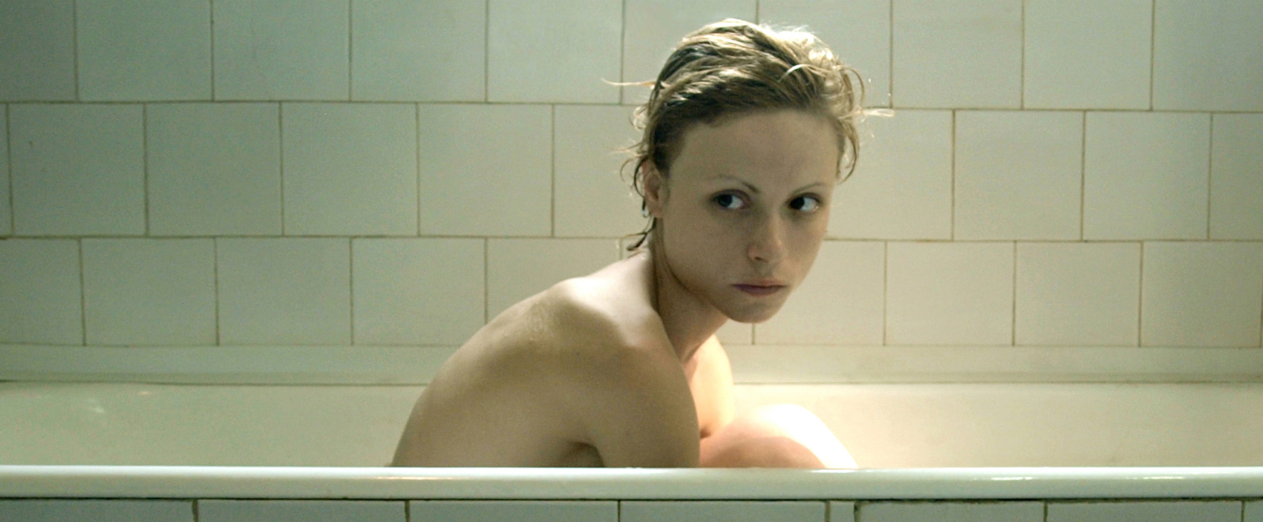

SILENT ONES / SCREENER LINK
Link Silent Ones Screener : https://vimeo.com/119985553
Password: SilentOnes-Screener

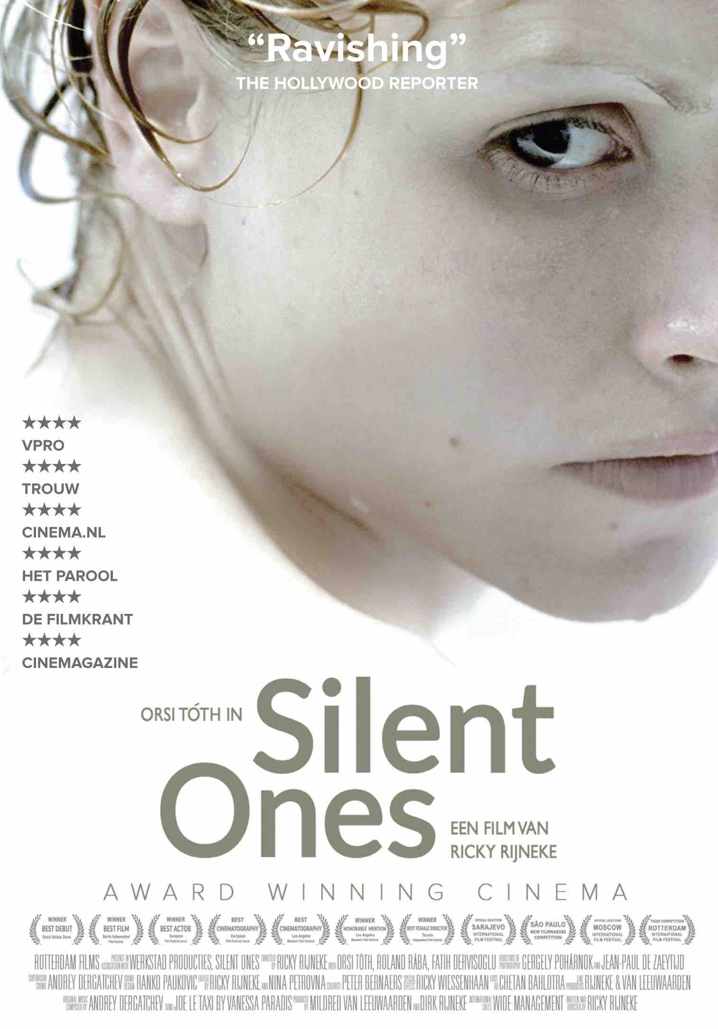

WING, the fish that talked back
Ricky Rijneke’s debut short film Wing, the fish that talked back (13 min) tells the story of six-year-old Wing, who is living in a fantasy world created from the perspective of her everyday life.

The film premiered at the 60th Locarno International Film Festival and was nominated for the Golden Leopard. It was a true festival hit and gained international acclaim at more then 50 international film festivals such as Ghent (Prix-UIP), Toronto, London, San Francisco (Golden Gate), Denver, Rotterdam, Bilbao, Hamburg, Guanajuato, Guangzhou, Bucharest, Teheran, Rio de Janeiro, Courts Métrages, Festival de Cine Europeo, Manaki Brothers and many others.

This multi-award winning film was sold to several broadcasters and released in Sweden, Switzerland, Spain, Poland, Croatia, France and The Netherlands.
Distributer: EYE (NL). World Sales: Elypse Distribution (Spain).

★★★★★ – Cinemagazine
‘Successful poetic debut that will warm your heart.’
– San Francisco Int. Film Festival: ‘Dutch filmmaker Ricky Rijneke has a commanding sense of cinematography. Definitively a filmmaker to watch.’
Trailer: https://www.youtube.com/watch?v=AZ0K-GVOvAs

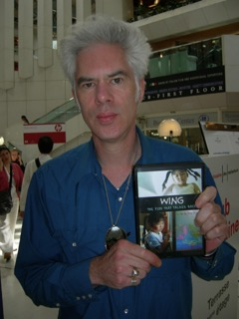

WING SCREENER LINK
Link Wing, the fish that talked back Screener
https://vimeo.com/181034213

Password: Wing

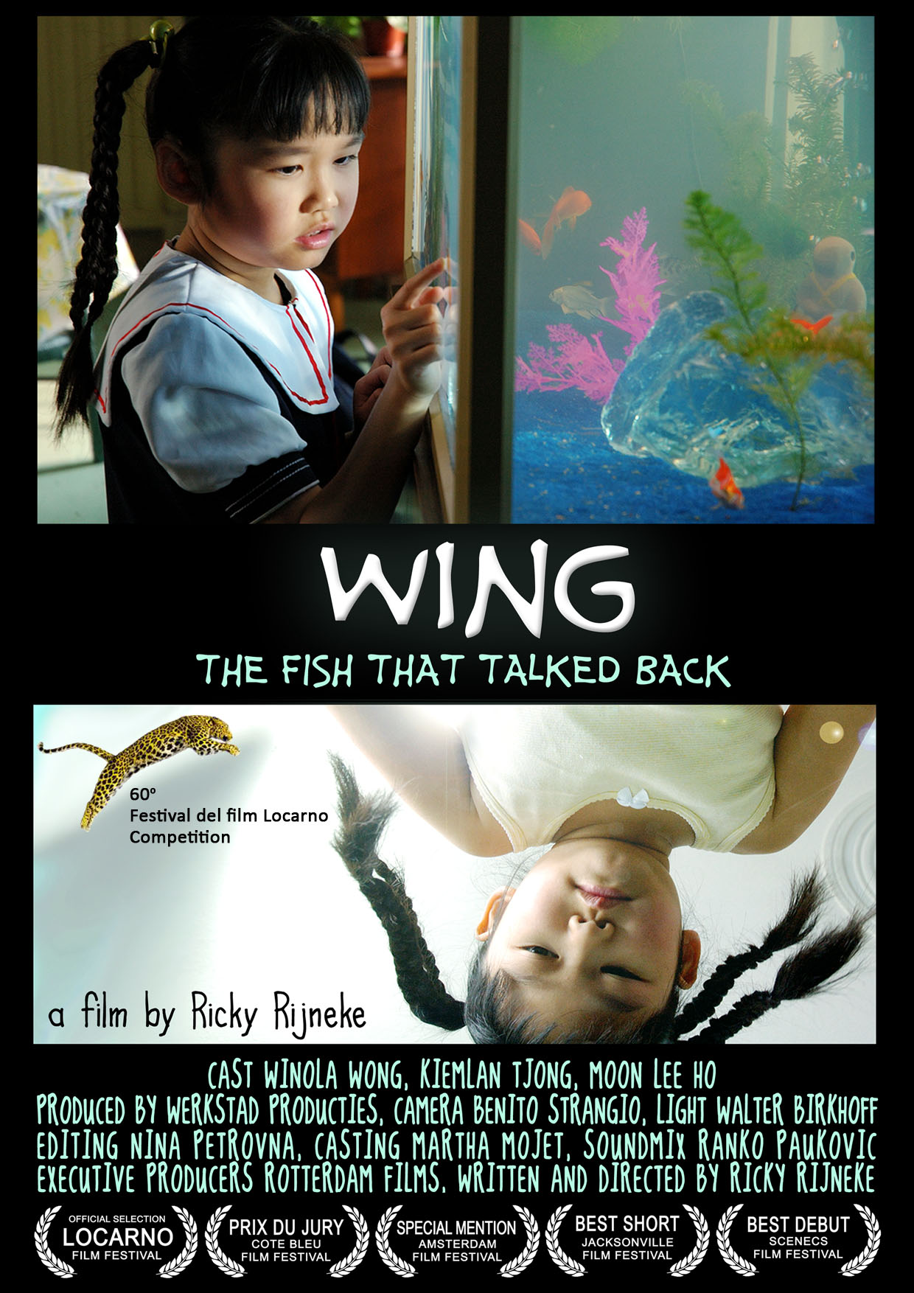
Jim Jarmusch

